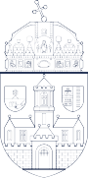**NEUMANN JÁNOS**

**FACULTY OF INFORMATICS** Annex 5

THESIS

|  |  |  |
| --- | --- | --- |
| **OE-NIK** | Student’s name: | **Barta, Zoltán Kevin** |
| **2024** | Student’s registration number: | **T-006056/FI12904/N** |